# Book Description

Humans have evolved over many centuries to be the dominant species on this planet, with the highest intelligence and astonishing brainpower. So what exactly does that look like? How do our brains and thought patterns really work, and how do they relate to our actions? In this guide, you’ll learn that you are in control of your mind and actions, even though we so often feel like we aren’t in control. All it takes is a little practice and training, and a deeper understanding of how your brain works. You can break undesirable habits and implement new, healthier ones, and with your enhanced understanding of human emotion and psychology, you’ll be better equipped to help others improve their lives in the same way.

The Habit Paradox

A Glimpse into Human Behavioral Variations

**Megan Allred**

# Table of Contents

Introduction

Chapter 1: The Mystique of the Human Psyche

Technology

Comparative: Man vs Beast

Chapter 2: Creatures of Habit

Built In

Good vs Bad Habits

Addiction

Chapter 3: Taking Control

Programming Your Mind

It’s A Process

Keeping It In Check

Chapter 4: The 21 Day Challenge

Chapter 5: A New Leaf

Conclusion

References

# Introduction

Most humans, at one point or another, have likely felt like they weren’t in control of their thoughts or possibly even their actions. It’s easy to feel like your imagination is “running away with you,” or to experience intrusive thoughts that you don’t want, which can be quite scary. Many of these psychological phenomena often result in habits or actions that otherwise would not occur, and the combination of your mind having a mind of its own (so to speak) and causing you to perform actions that you otherwise wouldn’t can be a terrifying experience. Feeling as though you don’t have control over your own mind and body is one of the most unnerving mindsets to be in, but most of us have been there.

Fortunately, it’s a very manageable problem. Though it may feel impossible to conquer, all you really need is some knowledge and to train your mind a bit. It is *your* mind, make no mistake, and it obeys *you*, not the other way around. You deserve to feel in control of yourself and your life, without your pesky brain interfering in negative ways, so that is what this guide seeks to help you achieve. By the end of this book, you will have a much better understanding of how our brains work, how habits develop, and how you can change them however you wish.

# Chapter 1: The Mystique of the Human Psyche

Studying and understanding the workings of the labyrinthian human mind is so complex that it spans multiple disciplines, and people can easily spend their lives doing so without fully comprehending it. Still, even if you are not seeking a psychology degree, it is beneficial to have at least a cursory knowledge of our thoughts, thought patterns, and brain functions. 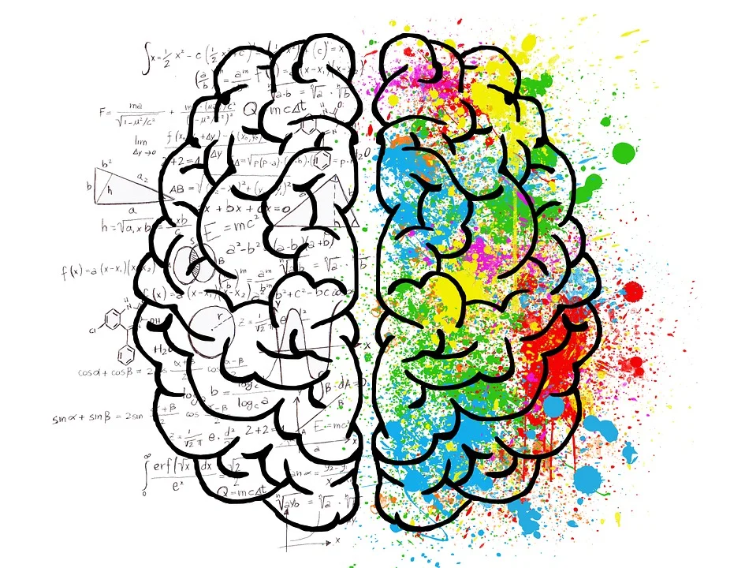

Psychology is broken up into many subcategories and branches; there are specialties which study social psychology, abnormal psychology, cognitive psychology, neuropsychology, and dozens of others. Behavioral psychology is a branch as well, but behavior itself is ingrained into several other areas of the mind covered by other branches. For example, cognitive psychology tends to view the brain as a kind of computer, receiving information as “input” via your senses and processing or storing it before producing an “output,” or behavior. Social situations affect our behavior too, so social psychology also relates to our behavior. Actions are inherently related to our brains and thoughts, and these links are spread throughout the areas of the brain.

Here is a summary of behavior psychology, according to Dr. Bryn Farnsworth:

In scientific research, human behavior is a complex interplay of three components: actions, cognition, and emotions. [...]

An action denotes everything that can be observed, either with bare eyes or measured by physiological sensors. Think of an action as an initiation or transition from one state to another – at a movie set, the director shouts “action” for the next scene to be filmed.

Behavioral actions can take place on various time scales, ranging from muscular activation to sweat gland activity, food consumption, or sleep. [...]

Cognitions describe thoughts and mental images you carry with you, and they can be both verbal and nonverbal. “I have to remember to buy groceries,” or “I’d be curious to know what she thinks of me,” can be considered verbal cognitions. In contrast, imagining how your house will look like after remodeling could be considered a nonverbal cognition.

Commonly, an emotion is any relatively brief conscious experience characterized by intense mental activity, and a feeling that is not characterized as resulting from either reasoning or knowledge. This usually exists on a scale, from positive (pleasurable) to negative (unpleasant).

Other aspects of physiology that are indicative of emotional processing – such as increased heart rate or respiration rate caused by increased arousal – are usually hidden to the eye. Similar to cognitions, emotions cannot be observed directly. They can only be inferred indirectly by tracking facial electromyographic activity (fEMG), analyzing facial expressions, monitoring arousal using ECG, galvanic skin response (GSR), respiration sensors, or self-reported measures, for example.

Actions, cognitions and emotions do not run independently of each other – their proper interaction enables you to perceive the world around you, listen to your inner wishes and respond appropriately to people in your surroundings. However, it is hard to tell what exactly is cause and effect – turning your head (action) and seeing a familiar face might cause a sudden burst of joy (emotion) accompanied by an internal realization (cognition). In other cases, the sequence of cause and effect might be reversed: Because you’re sad (emotion) and ruminating on relationship issues (cognition), you decide to go for a walk to clear your head (action). (Farnsworth, 2019)

So, in essence, cognition, emotion, and action are somewhat of a cycle; they drive each other. The more experts learn about psychology, the more mysteries they uncover. The famous nature/nurture debate is now more of an understanding that there are aspects of both driving our behaviors.

Cognitive psychology focuses on the processes that occur inside the mind; attention, thinking, memory, perception, language, learning, problem solving, et cetera. Thus, it has a wide reach, and covers a lot of issues, ranging from memory disorders to learning disorders and recovering from brain injuries. This area of study is crucial, because the more experts can understand our thought processes and how our minds work, the more methods we can develop for helping people with a wide range of mental challenges. Cognitive psychology has already been instrumental in studying and learning, for example, how attention works, and how we form, process, and store memories. Vital subjects to research in order to perhaps treat attention deficit disorders, or memory loss issues.

A tool that has been widely used and studied in the field of behavioral psychology is called **conditioning.** This concept was first developed and studied by Russian psychologist Ivan Pavlov, in his famous experiments involving dogs. His specific method is called **classical conditioning**, in which one is trained (whether intentionally or unintentionally) to react a certain way to a certain stimulus. In Pavlov’s experiments, this involved the observation that his dogs would salivate not only when presented with food, but also when the person feeding them came into proximity. The dogs were accustomed to relating a person approaching them with food with being fed and responding to the person as the stimulus rather than just the food. Pavlov was also able to condition the dogs to salivate in response to opening the door through which food was normally given, whether or not food was actually provided.

Later, psychologist B.F. Skinner furthered the research into conditioning and developed his own theories, with his research resulting in the discovery of **operant conditioning** as well as positive and negative reinforcement. Positive reinforcement involves providing a positive result (may be a reward, or praise, etc.) for actions you want to encourage, and negative reinforcement is rewarding for *not* displaying undesirable behavior. There is also positive punishment, in which an unpleasant result is given (reprimand, pain, etc.) to discourage undesirable behaviors. Keep these tools in mind later when we discuss habits more.

## Technology

We live in a digital age; that much is indisputably clear. We exist in an age of incredibly advanced technology that gets more and more advanced every day, with an infinite wealth of information at our fingertips at all times. On the surface this looks like an amazing thing, and it is, but it has turned out to be somewhat of a double-edged sword that has created its own set of unique problems. The negative effects of technology are especially noticeable in children and teens. Research has shown that screen time and social media usage have negative effects on kids’ mental health, social skills, and attention, and that when they are on electronic devices for extended periods of time each day, they are more likely to display behavioral problems such as lying and fighting. More screen time is linked with symptoms of Attention Deficit Hyperactive Disorder (ADHD), lower academic performance, depression, anxiety, loneliness, and low self esteem (Children’s Bureau, 2019; Jones, 2017).

Adults are not immune to the negative effects of our digital age either. Ironically, social media use is linked to feeling more socially isolated than those who don’t often use social media. Adults also often experience eye strain, poor posture, sleep problems, and reduced physical activity as a result of being glued to technology. In many cases, these things can actually qualify as an addiction to technology or the internet.

The reasons for these negative effects are somewhat unclear, and probably vary from person to person. It could be that we don’t interact with one another face-to-face as much as we once did, or that we are bombarded with images and information about people who are more successful and attractive than us. Technology has made it so that literally just about everything is just a few buttons away, so we have gotten accustomed to instant gratification; any question can be answered instantly with a quick search, any craving can be quenched with a Doordash delivery, all the information and products are readily available. Impatience and the expectation of instant gratification have never done anyone any favors, but here we are, spoiled by technology.

The intent here isn’t to demonize technology; if we have learned anything throughout the past year or so, it is that technology absolutely has its place and uses. Without the technology we have, the COVID-19 pandemic would have been even more devastating, preventing millions of people from working or talking to loved ones or having essential supplies delivered to their homes (not to mention dying of boredom during long lockdowns). Having so much information available and so much access to people and products and data we need is important and wonderful, but all things in moderation. Too much of a good thing--including technology--can clearly still be harmful, and too much screen time is a habit many of us could stand to break.

## Comparative: Man vs Beast

Though our brains and thought processes differ greatly, we can learn a lot about human psychology and behavior by studying the behaviors of animals. Remember Pavlov’s dogs? There are many similarities in behavior shared across numerous species, and an entire discipline exists for studying this: comparative psychology. In fact, many of the revered behaviorists like Pavlov and Skinner believed that the laws of learning were the same across all species.

At our biological cores, every species’ course of action and primary instinct is that of survival. Our evolutionary imperative is to live and thrive, but this is achieved differently for each species. That isn’t to say that individual survival is the most important thing and that each species operates on a “survival of the fittest” philosophy; our survival instinct also relates to the survival of our species, and therefore our young and our communities. Across species, our behaviors follow many of the same rules. Nearly every species responds to different types of reinforcement, and many species (including humans) display behaviors of territoriality, following a hierarchy or “pecking order,” playing, defending our offspring, becoming aggressive when threatened, and practicing courtship or mating rituals. Famous psychologist Sigmund Freud conducted a significant amount of his research by observing apes. Skinner often used pigeons and rats. The findings from research that has been conducted observing the behaviors of animals have been overwhelmingly helpful in the development and application of the most prominent, successful types of therapy.

There are, of course, differences. Human minds are often described as much more sophisticated than other species. Our communication differs greatly; humans rely primarily on verbal speech, whereas other animals have a variety of communication mechanisms such as body language or signals, and their communication tends to be of the “here and now” variety while humans regularly discuss things in different places and times as well as abstract concepts. Our actions are generally the product of a conscious decision rather than an instinct or drive, and herein lies the evidence that we as humans differ from animals in that we can control and change our thoughts and actions.

# Chapter 2: Creatures of Habit

In psychology, a habit is “...any regularly repeated behaviour that requires little or no thought and is learned rather than innate. A habit—which can be part of any activity, ranging from eating and sleeping to thinking and reacting—is developed through reinforcement and repetition.” (Encyclopaedia Brittanica, 2014) The more this action is repeated, the more automatic it becomes. 

You may have heard the phrase, “We are creatures of habit,” at some point, and it is quite true for humans. Habits exist even in ways you don’t think about; you perform automatic actions when you do things like brush your teeth, or take the milk out of the fridge, or put on your shoes, because you do these things so frequently that you no longer need to think about. Some habits take longer to form, like learning to parallel park or wash the dishes, but after you’ve done them enough times they are automatic too. In many ways, habits are important because they are efficient. If we had to devote time and energy to consciously thinking through every step of every mundane everyday task, it would be exhausting and wasteful of our body and mind’s resources.

A lot of this description may sound more like a routine than a habit, and they are similar concepts, but a routine is not quite as ingrained as a habit is. You generally still have to think through the steps of a routine, you don’t just automatically go through the motions.

## Built In

So how do these habits get so ingrained into our brains? They are constructed through repetition and learning. Essentially, you begin to associate a certain cue with a certain behavioral response, usually in the pursuit of a goal. It becomes a cycle, in which a behavior instigates itself as a response to a cue in your life or routine.

The cue tells your brain to go into autopilot and allow a certain action to be performed, and after the action there is a “reward,” or result that the brain likes, which helps it remember this habit cycle in the future.

Scientists theorize that our habit-related processes take place in a part of our brains called the basal ganglia. This area of the brain is said to be highly involved in action selection and behavior execution-- controlling, regulating, and choosing which actions to perform at a given time. The basal ganglia also plays an important role in memories, pattern recognition, and emotions. It is not, however, involved in conscious decision making. In fact, when engaging in a habitual behavior, the decision making area of the brain sort of shuts down, to preserve mental energy and space for other activities. This is why it’s so easy to focus on something else when you’re performing automatic, habitual actions like driving or washing your hands.

## Good vs Bad Habits

Habits are an integral and, as we have learned, often subconscious part of our lives, actions, and psyches. Once it has become an automatic action, your brain no longer questions why it is carrying out the action or scrutinizing the outcome. Nearly any action can be a habit if implemented repetitively enough and in the right manner, and not every action is a good or healthy one, so it stands to reason that not every habit is good.

Good habits are, of course, habits that benefit you in some way. Some examples of good habits are brushing your teeth every morning and night, drinking water throughout the day, beginning each day with a healthy breakfast, exercising, reading before bed, complimenting your spouse, recycling, and treating people kindly and respectfully. Good habits can be good for your physical or mental health, for your career or future prospects, for the environment, for your friends or family, or just for the benefit of the people around you. Some good habits happen automatically, especially if the result or reward is important or meaningful to you. Some are more challenging to implement.

Bad habits tend to be much easier to fall into, and much harder to break. These are the habits that can be harmful to you, the people around you, or the environment. Some common bad habits that people often want to change are smoking, drinking, overeating, swearing, spending too much time on social media or watching TV, shopping too much, or biting fingernails. Most of the time there is some underlying reason for these habits, whether they are simply pleasurable, or if there is some void they are filling or subconscious psychological need they are satisfying.

## Addiction

Unfortunately, some bad habits can spiral into something more serious, in which your body develops a chemical dependency. These addictions can quickly and easily turn into incredibly destructive behaviors and lifestyle choices that can have extreme--even deadly--consequences. They are also very difficult habits to break, and some people are never able to.

Addictions also differ from habits in that they are usually not subconscious at all, eventually. Often they are quite the opposite; people will go to extreme, destructive lengths to satisfy their addictions, to the point that it can take over their lives and destroy their relationships. The addiction alters their brain functions to the point that it’s all they can think about, and they become so intensely fixated that they will often do just about anything to satisfy that need. The chemical aspect of addiction makes it a much harder kind of habit to break than other bad habits, because your body thinks it needs the substance. There are also psychological and behavioral addictions, which manifest similarly but have different causes and scientific explanations; for example, sex addiction. Most all addictions affect your ability to control your impulses and behaviors.

While addictions are more difficult to get out of, it is certainly possible, and you can often do so using the same methods for altering behaviors and breaking habits that will be outlined later. It should be clarified that while it is of course very possible to tackle addiction yourself with habit-breaking methods, we are not trying to discourage anyone from seeking professional help if needed; treating some addictions requires the assistance of trained professionals, for your own safety and well-being, and there is absolutely nothing wrong with that. We simply acknowledge that some may not have access to those resources, and many people may find it easier and more effective to take matters into their own hands and take the steps to break these destructive habit cycles at their own pace.

So how do you tell when your habit has become an addiction? Some clues to distinguish between the two lie in whether or not the action or routine is (or could be) harmful to you. Does it negatively affect you, your health, or your life? Does it put you into dangerous situations? Do you experience negative effects when you are unable to do it? Have you tried to stop unsuccessfully before? Do you hide it from people? It can be incredibly difficult to admit to yourself that you are struggling with an addiction, but as the famous saying goes, the first step is admitting that you have a problem.

# References

Cherry, K. (2019, November 4). *How cognitive psychology explains the science behind mental processes*. Verywell Mind. https://www.verywellmind.com/cognitive-psychology-4157181.

Children's Bureau. (2019, September 30). *Effects of technology on children & mental health*. Child Abuse Prevention, Treatment & Welfare Services . https://www.all4kids.org/news/blog/effects-of-technology-on-mental-health/.

Editors of Encyclopaedia Brittanica. (2014, September 8). *Habit*. Encyclopædia Britannica. https://www.britannica.com/topic/habit-behaviour.

Farnsworth, B. (2019, July 4). *Human behavior: The complete pocket guide*. iMotions. https://imotions.com/blog/human-behavior/.

Johnson, J. (2020, February 25). *Negative effects of technology: Psychological, social, and health*. Medical News Today. https://www.medicalnewstoday.com/articles/negative-effects-of-technology.

Jones, A. (2017, May 3). *More technology use linked to mental health issues in at-risk adolescents*. Duke Today. https://today.duke.edu/2017/05/more-technology-use-linked-mental-health-issues-risk-adolescents.

Marston, D. (2019, December 30). *Insights on how animal and human psychology relate*. Psychology Today. https://www.psychologytoday.com/us/blog/comparatively-speaking/201912/insights-how-animal-and-human-psychology-relate.

Mcleod, S. (2015). *Comparative psychology*. Simply Psychology. https://www.simplypsychology.org/comparative-psychology.html.

NPR. (2012, March 5). *Habits: How they form and how to break them*. NPR. https://www.npr.org/2012/03/05/147192599/habits-how-they-form-and-how-to-break-them.

*What is conditioning and how can it influence our behavior?* Psychologist World. (2015, January 1). https://www.psychologistworld.com/memory/conditioning-intro.